**Editor**

**Your submitted paper has undergone peer review. Thank you for carefully addressing all the comments you received. You will find some residual ones at the end of this correspondence. I personally still have a problem with the figures. They are atypical and I want to make sure our readers understand them. I think I do but am not sure.**

**1. Please use the title and footnotes to explain what the data show. A lesser gain in life expectancy in the more recent decade compared to the previous decade is understandable. But a lower reduction in inequality of life expectancy for the recent decade ... is harder to digest. The figure should say how you define inequality.**

We have rephrased the title of figure 1 and included a footnote explaining what lifespan inequality is:

Title Figure 1: Changes in male life expectancy at age 15 (panel A) and in male lifespan inequality at age 15 (panel B) by state for the periods 1995-2005 (blue dots) and 2005-2015 (red triangles).

Figure 1 notes: Lifespan inequality refers to life years lost due to death, which indicates heterogeneity in ages at death. A value of zero in lifespan inequality indicates that all cohort members die at the same age (i.e., no inequality in ages at death). This figure shows how lifespan inequality changed in two periods: positive values suggest increases in years of life lost and negative values correspond to reductions in life years lost due to death. Hence, the desirable association would be that as life expectancy increases, lifespan inequality decreases. This figure shows each of the 32 Mexican states grouped in broad regions: North, Central, South. Within each region, states are ordered according to the magnitude in changes in life expectancy at age 15 in the period 2005-2015.

**2. In Figure 1 the ranges of the x-axis should be identical for both panels. Otherwise you need to use two figures.**

We have changed the figure accordingly, now it looks like

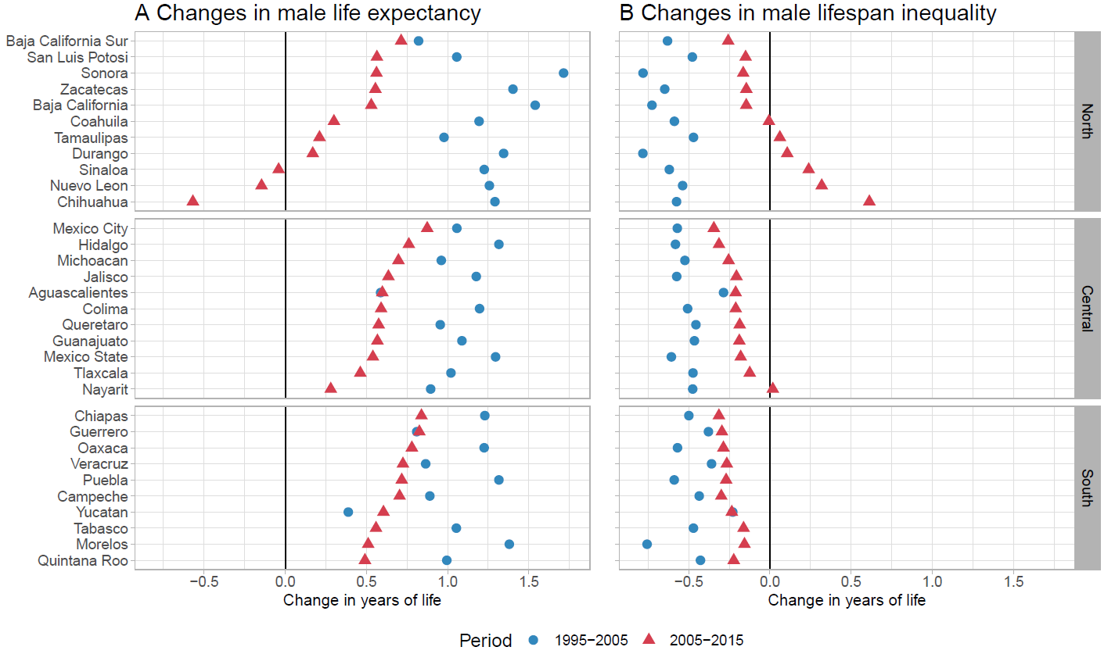

**3. Why are the geographical locations (you need to say what they are, states?) grouped the way they are?**

The figures show each of 32 states in Mexico. We have clarified this in the figures notes. We grouped the 32 states in three areas that generally represent major geographical locations in the country: North, Central, South. These three regions broadly correspond to areas that clearly show a differential impact of violence on the population (see Aburto et al, 2016 and Flores and Villareal, 2015).

Figure 1 notes: Lifespan inequality refers to life years lost due to death which indicates heterogeneity in ages at death. A value of zero in lifespan inequality indicates that all cohort members die at the same age (i.e., no inequality in ages at death). This figure shows how lifespan inequality changed in two periods: positive values suggest increases in years of life lost and negative values correspond to reductions in life years lost due to death. Hence, the desirable association would be that as life expectancy increases, lifespan inequality decreases. This figure shows each of the 32 Mexican states grouped in broad regions: North, Central, South. Within each region, states are ordered according to the magnitude in changes in life expectancy at age 15 in the period 2005-2015.

Figure 2 notes: This figure shows how homicides contributed to changes in lifespan inequality (i.e., panel B of Figure 1) in two periods: positive values suggest increases in years of life lost due to homicides and negative values correspond to reductions in life years lost due to death. This figure shows each of the 32 Mexican states grouped in broad regions: North, Central, South. Within each region, states are ordered according to the magnitude of the impact of homicides to lifespan inequality at age 15 in the period 2005-2015.

References:

Aburto JM, Beltrán-Sánchez H, García-Guerrero VM, Canudas-Romo V. Homicides in Mexico reversed life expectancy gains for men and slowed them for women, 2000–10. *Health Affairs.* 2016;35(1):88-95

Flores M, Villarreal A. Exploring the spatial diffusion of homicides in Mexican municipalities

through exploratory spatial data analysis. *Cityscape.* 2015;17(1):35.

**4. The title is also much too complicated. Try: "Relation of Homicides to life expectancy in Mexico, 2005-2015."**

We concur with the editors that the title is perhaps too complicated. We want to indicate in the title the main contribution of our work, namely, the use of lifespan inequality alongside life expectancy as an indicator of population health. We suggest the following title: ‘The upsurge of homicides and its impact on life expectancy and lifespan inequality in Mexico, 2005-2015’

**Reviewer #1 spotted a probable typo that has to be fixed; I consider the other remarks optional and leave it to the discretion of the authors to incorporate them or not.**

We have fixed the typo.

**Reviewer #1**

**Reviewer #1: My thanks to the authors for providing such a detailed and considered response to the reviewer comments, and to the other reviewers for their very thoughtful and informative suggestions.  
  
I think many of the revisions the authors have made, particularly in providing additional context in the introduction and discussion sections and adjusting the presentation of the results, have helped strengthen the paper. I also greatly appreciate the efforts the authors made to clarify other smaller points, and to re-analyze the data using cause-of-death data below age 85.  
  
I have just a couple minor additional comments on reading the revised version which I will provide below.   
  
Results: page 7 the authors write, "Importantly, homicides declined in 1995-2005 which accounted for about 38.5% (0.45 years) of the overall gain in life expectancy in this period." In graph S2A it appears that the value for homicide is 0.44 years instead of 0.45. Perhaps this is a minor typo?**

Thank you for catching this error, it was a typo due to rounding, we have corrected it.   
  
**Discussion: On page 10, add word male before life expectancy to this sentence, since the referenced figure S7 depicts only male life expectancy: "For example, almost every state experienced a reduction in life expectancy at age 15 across all regions in Mexico due to homicides (SM figure 7)."**

We have made the change as suggested.  
  
**On page 12, I think the recommendation to focus on women in future research might warrant including a brief mention that violence often affects people significantly even if they are not the direct victim of the crime. For example, women are often placed in a caregiving role where they are caring for loved ones who are victims of violence, and their lives are often profoundly affected by that. I think this also connects to Reviewer 3's observation that there are broader population health impacts of violence beyond measuring homicide. Because this paper is focused on "the most severe form of violence--homicide" I do not think this point necessarily requires in-depth elaboration. But I think it is worth mentioning as an important area of future research, because a broader perspective on the effects of violence might potentially help account for the apparent paradox that "females are less likely to experience a crime but they perceived greater vulnerability."**

We have added the next sentence:

“Moreover, often women are placed in caregiving roles for victims or experience the loss of close relatives due to violence that affect their lives and psychological wellbeing.”

**Minor re-phrasings: There were a few passages where sentences were a bit confusing to follow and might need to be slightly re-phrased:**  
  
**Page 9: "In the same period, all but two states for males, Baja California Sur in the North and Tlaxcala in the central region decreased lifespan variation attributed to improvements in medically amenable conditions" --possible missing word? Might read a little more clearly to say: "In the same period, all but two states for males, Baja California Sur in the North and Tlaxcala in the central region, showed decreased lifespan variation attributed to improvements in medically amenable conditions"**

We have followed the suggestion.  
  
**Page 11: it might read a bit easier to break the following sentence into 2 sentences: "The strongest effect occurred in Guerrero, a state in the Southern region, where life expectancy was reduced by almost 2 years between 2005 and 2015, followed by Chihuahua and Sinaloa in the North, with life expectancy losses of one year each, three additional states in the North (Zacatecas, Baja California Sur and Nuevo Leon), one in the Central region (Colima), and on in the South (Morelos), experienced losses of half a year in expectancy."**

We have followed the suggestion, it now reads:

‘The strongest effect occurred in Guerrero, a state in the Southern region, where life expectancy was reduced by almost 2 years between 2005 and 2015, followed by Chihuahua and Sinaloa in the North, with life expectancy losses of one year each. Other states also experienced reductions in life expectancy albeit of lower magnitude, three states in the North (Zacatecas, Baja California Sur and Nuevo León), one in the Central region (Colima), and one in the South (Morelos), experienced losses of half a year.’

**Page 14: This sentence appears incomplete and might be missing a word: "For example, programs on improving schooling outcomes and educational and community programs to reduce the risk factors of violence (e.g. alcohol consumption) among others."**

It now reads:

‘For example, other countries that underwent a similar upsurge of violence associated with drug cartels successfully implemented programs on improving schooling outcomes and educational and community programs to reduce the risk factors of violence (e.g. alcohol consumption)’